**Telnet into Cisco Router with Python**

Author: David O. Folorunsho

Date: 27th September, 2023.

Description: How to Telnet into a Cisco Router c7200 with Python

Task:

1. Design the topology.

    i. Select Cisco router c7200 and Management Cloud Network

   ii. Connect the Cisco router and the Management cloud

Note: Arrange the nodes (c7206VXR) and Management Cloud Network (Net).

2. Basic Router Configuration and Telnet Setup.

    i.  Hostname

   ii.  Enable Secret Password

  iii.  Local Telnet Username & Password

  iv.  Configure VTY line access,

   v.  Config DHCP client on the interface connection to Management Cloud Network

  vi.  Write configuration to NVRAM (To save configurations) Note: Verify that the router interface gets IP from the Management Cloud Network. Use the IP to Telnet into the eve-ng router using Putty from outside eve-ng. The router inside eve-ng must be accessed through this telnet from outside.

3. Telnet with Python code.

     i. Develop python code using Telnetlib or Telnetlib3 with the following step

        A.  Define the required libraries

        B.  Define the required variables.

        C.  Use the variables (IP, Username and password) to telnet to the router.

        D.  Execute some commands on the router

        E.  Generate command-line configuration

Note: Verify the python script. Run the script. By running the python script, the command ('some commands') should be executed on the c7200 router in the eve ng environment. Verify that the command executed has changed the running configuration of the router. You can also verify this by showing/comparing the running-configuration and startup-configuration.

1. Design the Topology

i. Select Cisco router c7200 and Management Cloud Network

ii. Connect the cisco router and the Management cloud

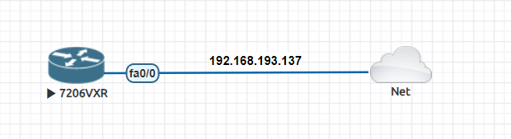

Note: Arrange the nodes (c7206VXR) and Management Cloud Network (Net).

2. Basic Router Configuration and Telnet Setup

i. Hostname

ii. Enable Secret Password

iii. Local Telnet Username & Password

iv. Configure VTY line access,

v. Config DHCP client on the interface connection to Management Cloud Network

vi. Write configuration to NVRAM (To save configs)

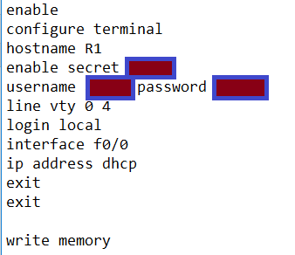

Note: Verify that the router interface gets IP from/thru the Management Cloud Network. Used the IP to Telnet into the eve-ng router using Putty from outside eve-ng. The router inside eve-ng must be access through this telnet from outside.

Verify that the interface IP address is reachable and other IP address

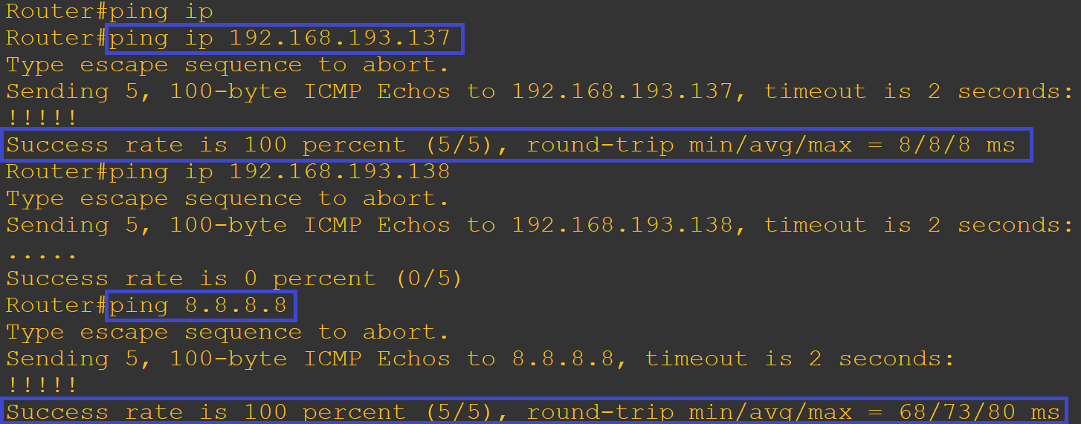

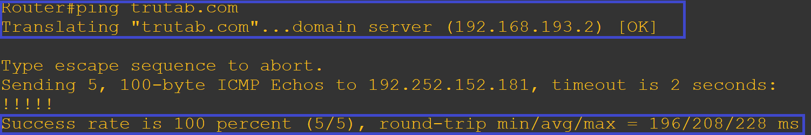

Using show command to verify interface IP address and interface status

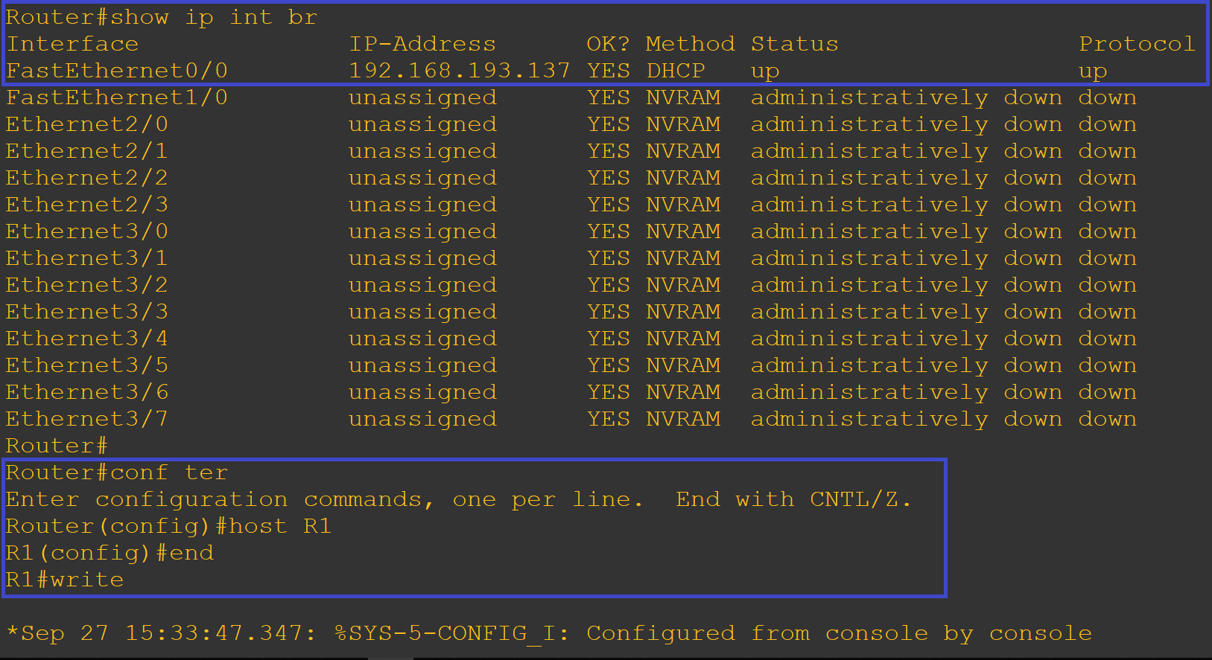

Save Configuration to NVRAM

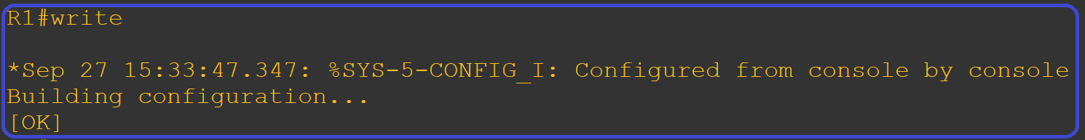

Verify that telnet is possible

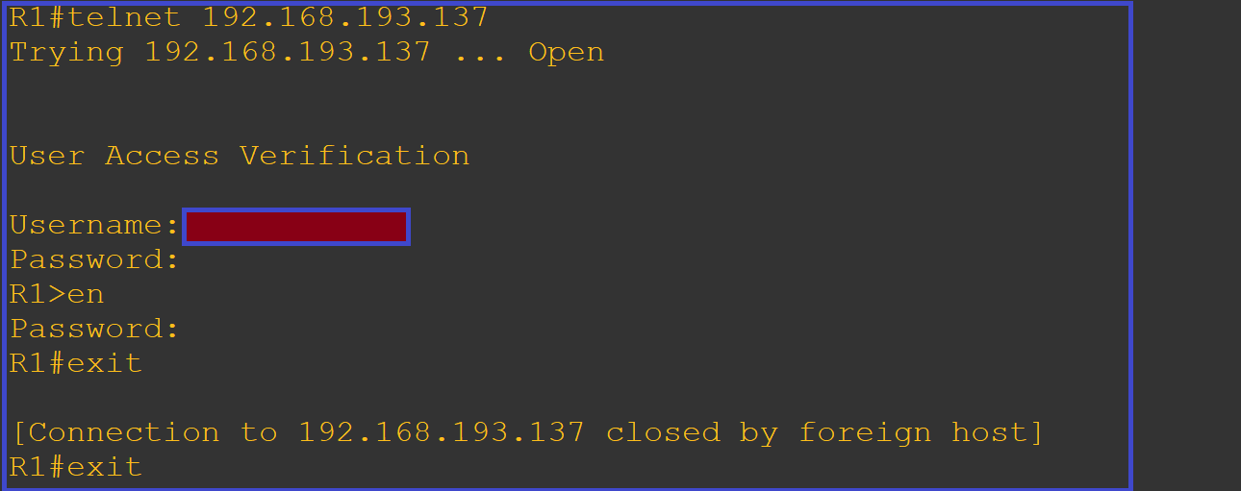

3. Telnet with Python code

i. Develop python code using Telnetlib or Telnetlib3 with the following step

A. Define the required libraries

B. Define the required Variables

C. Using the info (IP, Username and password) to telnet into the Router

D. Execute some command on the router

E. Generate command line configuration

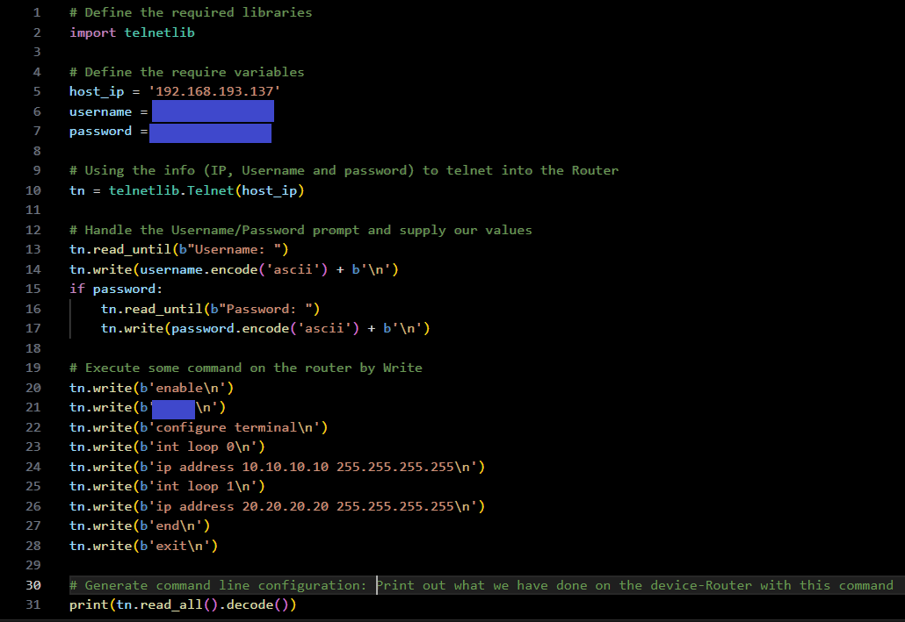

Note: Verify the python script. Run the script. By run the python script the command ('some command') should be executed in the c7200 router in the eve ng environment. Verify that the command executed has change the running configuration of the router. You can also verify this by showing /comparing the running-configuration and startup-configuration.

Run python script

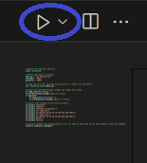

Below is the output by the Python script on the visual studio code terminal. It shows that the script was successfully executed. Two loopback interface was set with an IP address.

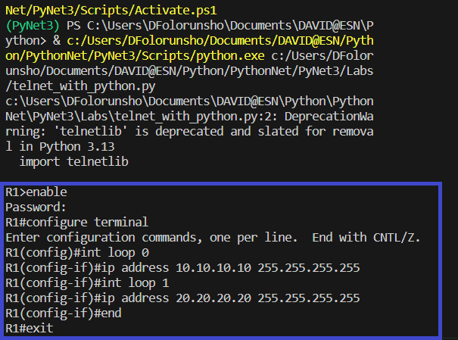

Also, the effect of the script can be seen simultaneously in the Logs in eve ng environment. The effectual output shows that two Interface; loopback 0 and 1 come up. In addition, this configuration was done via the vty0 line access with the IP 192.168.193.1. This IP is the PC IP used. Note: The Router IP address and the PC IP address are in same range.

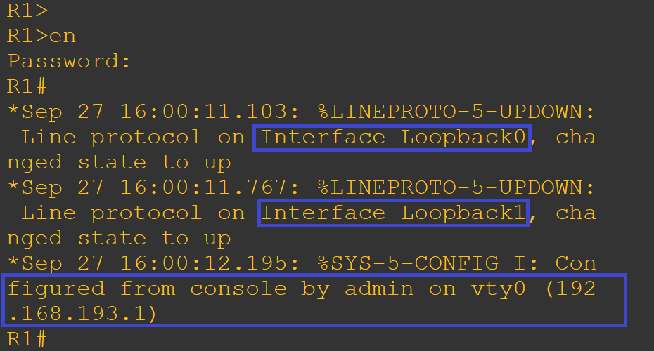

Verification

To verify complete that the change was properly done by the script, let compare the command output of “show commands” by using “show start-config” and “show running-config”

With “show startup-config”

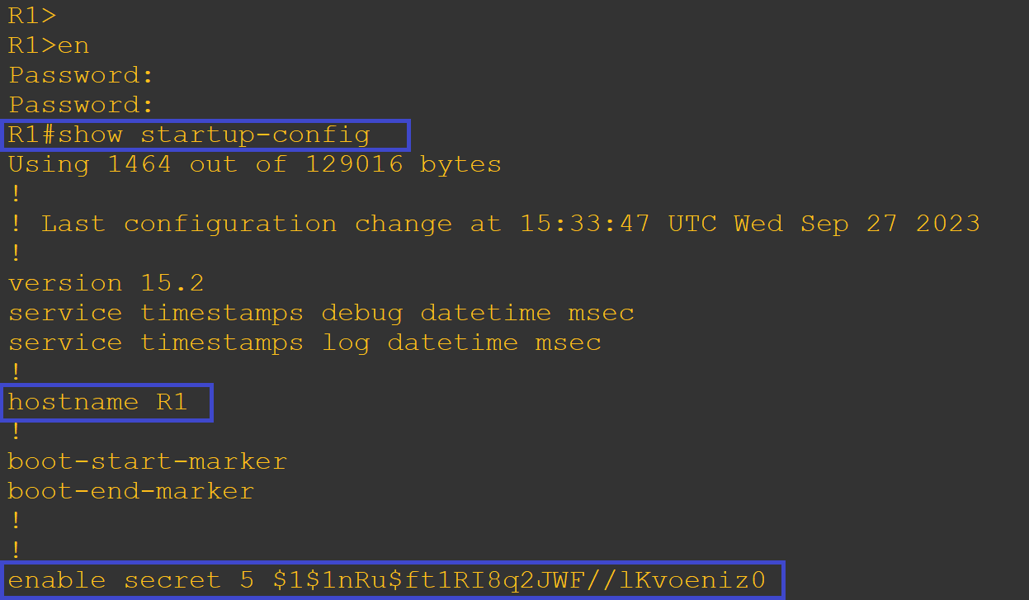

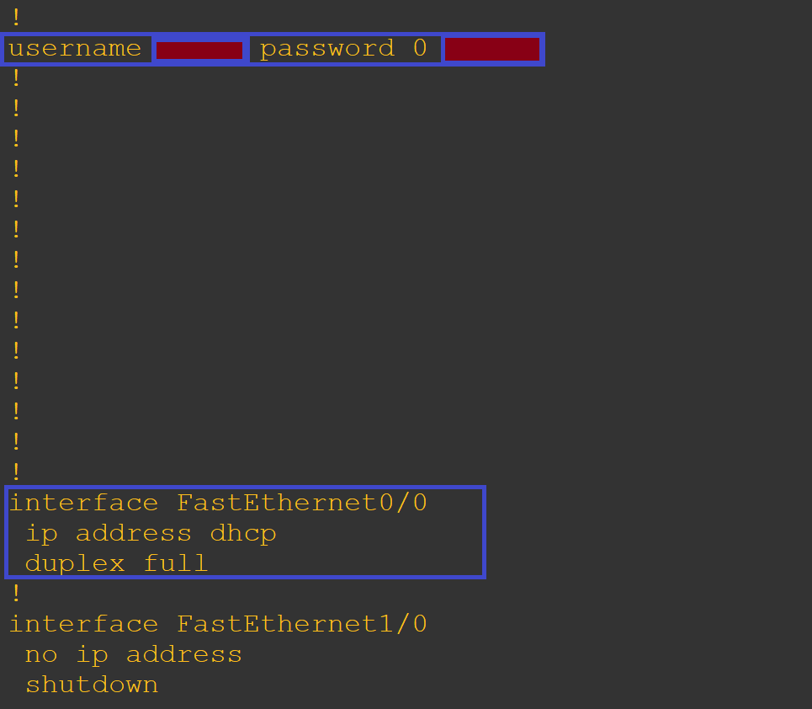

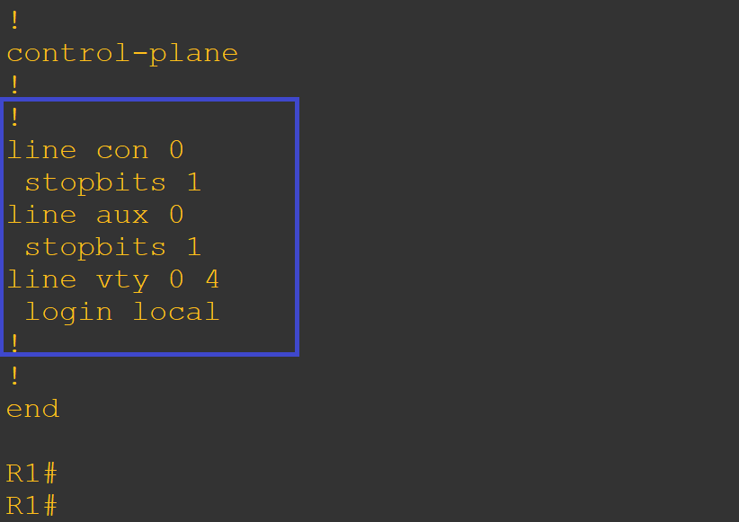

With “show run” command

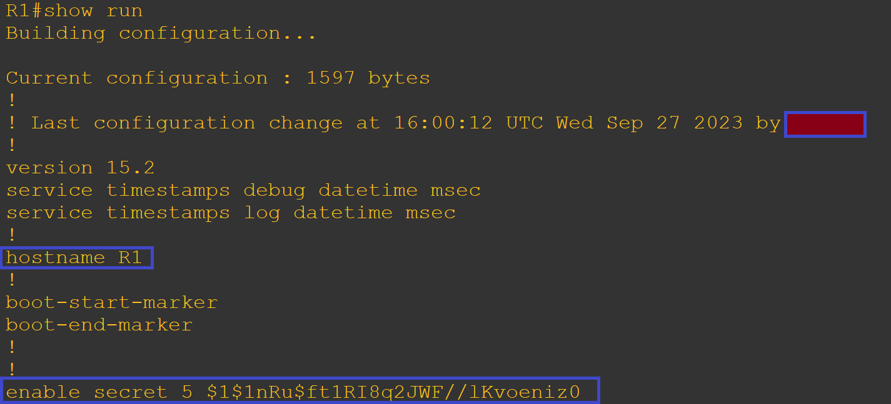

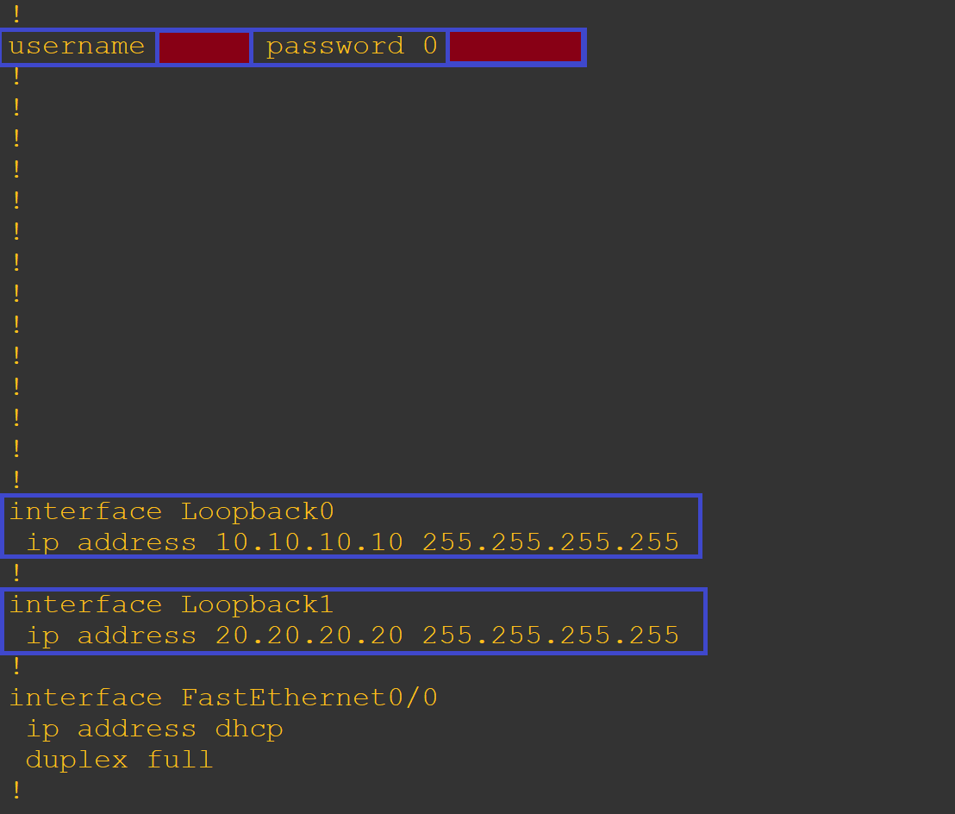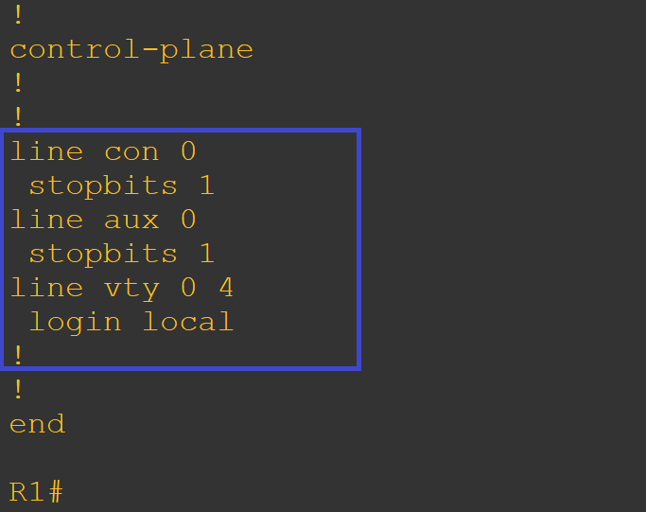

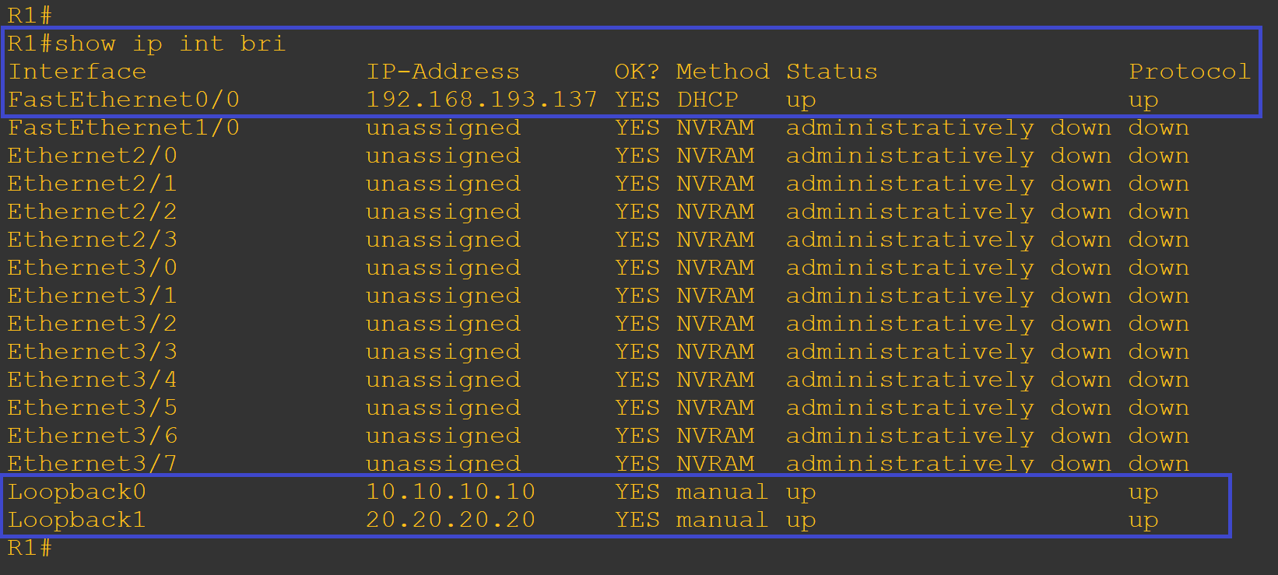

Python script was used to telnet into Cisco 7200 router and execute interface command.

Running python script to config a network device like router or switch take less that a second once the code has been developed.